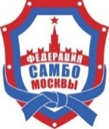
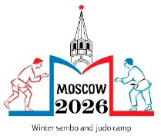


REQUEST
ACCOMMODATION

Responsible for accommodation  Pavlov Denis - +79067722514 | E-mail: sambo70camp@mail.ru

City, country
federation/club
Contact person
Tel.
E-Mail
number of participants участников
Coaches, officials представители
Athletes (male) (мужчины)
Athletes (women) (женщины)

№ | Full name | coach, athlete, officials | weight | Sambo, judo | Hotel accommodation | Early check-in, late check-out | Room category (single, double, triple) | Meals (breakfast, full) | Payment (cash, non-cash, contribution)
 | Ivanov Ivan | Athl. | 64 | sambo | 2-7.01 | - | double | full | cash
1
2
3
4
5
6
7
8
9
10
11
12
13
14
15

Please send your accommodation requests to sambo70camp@mail.ru no later than December 22, 2025.
All participants, regardless of status, must register online at mossambo.ru.

