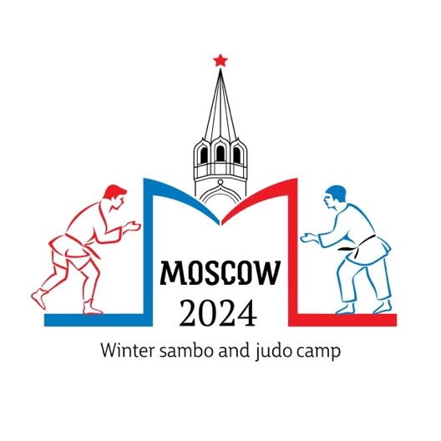

Open training camp for sambo and judo
among athletes over 17 years.
3-6 January 2024. Moscow, Russia.

1. Date
January 3th – 6th 2024
Training program is attached to the outlines!

2. Organizer
FSM- Federation Sambo Moscow
Address: 4-y Samotechnyy pereulok, 9
Moscow Tel: + 7 495 600-60-20
Russia Fax: + 495 600-61-08
Emergency Contact:Mr. Denis Pavlov Tel: +79067722514, Mail: sambo70camp@mail.ru

3. Venue
Sports and Education Center Sambo-70
Akademika Vinogradova str. 4 “b”, Moscow, Russia

4. Participation
All athletes can participate at the TC.

5. Age
17 years old and over (Born in 2006 and before)

6. Participation Fee
1000 RUB per participating athlete of Non-Federation Sambo Moscow member

7. Responsibility of the athletes
The athletes will train under the full responsibility of their National Federations or Sportclubs. Each National Federation or Sportclubs is responsible for insuring its athlete against ’injury and third part risk (public liability)’during the period of the camp. Sports and Education Center Sambo-70 decline all responsibility.

8. Transport
Transport from the airport to the hotel will not be.
Transfer from the hotel to the hall will be provided.

9. Accommodation
Official hotel for participants "Hotel ASTRUS", address: Moscow, Leninsky Prospekt 146.
To provide accommodation and meals, it is required to send an application for accommodation to the e-mail address of the sambo70camp@mail.ru to issue an invoice to the payer (organization and / or individual) by December 18, 2023.
Price: the price is per room per day (accommodation, partial or full meals, transfer hotel-hall-hotel, participation in the collection)

Room category | Breakfast | Breakfast-Lunch-Dinner
1-bed room | 4000 | 4200
2-bed room | 6000 | 6400
3-bed room | 8400 | 9000

Reservations will be processed strictly according to the date of your booking. In case your chosen category is fully booked, you will be informed and requested to make a new reservation.
Check-out not later than 12:00 am, otherwise an additional night will be charged.
Full board is starting with dinner on the day of arrival, and ending with lunch on the day of
your departure.

10. Registration
Starts on January 3th at 14:00 at Hotel “ASTRUS”, 146, Leninskiy av., Moscow.

11. Deadlines
Nominal Entry: 28.12.2023
Accommodation Entry: 18.12.2023
Visa Application: 03.12.2023

12. Cancellation policy
After December 25th 2023: no refund

13. Visa
For nations who need VISA to enter Russia, please send the enclosed “Visa Application Form”
fully filled not later than December 10, 2023 to sambo70camp@mail.ru.

14. Training program

Date | 9:45 – 11:00  (New complex) | 11:30 – 13:00  (New complex) | 16:00 – 17:30  (New complex) | 18:00 – 19:30  (New complex)
  3 January 2022 years – 17:30 Opening Ceremony
3 January 2023 |  |  | Men: under 71 kg.  Women: up to 72 kg.  5 x 4' – wrestling in the stalls  5x 5' – standing wrestling | Men:over 71 kg  Women:over 72 kg  5 x 4' – wrestling in the stalls  5x 5' – standing wrestling
4 January 2023 | Men: under 71 kg.  Women: up to 72 kg.  2 x 3' wrestling in the stalls  6 x 5' wrestling standing | Men:over 71 kg  Women:over 72 kg  2 x 3' wrestling in the stalls  7 x 5' wrestling standing | Men: under 71 kg.  Women: up to 72 kg.  2 x 3' wrestling in the stalls  7 x 5' wrestling standing | Men:over 71 kg  Women:over 72 kg  2 x 3' wrestling in the stalls  6 x 5' wrestling standing
5 January 2023 | Men:over 71 kg  Women:over 72 kg  2 x 3' wrestling in the stalls  6 x 5' wrestling standing | Men: under 71 kg.  Women: up to 72 kg.  2 x 3' wrestling in the stalls  7 x 5' wrestling standing | Men:over 71 kg  Women:over 72 kg  2 x 3' wrestling in the stalls  7 x 5' wrestling standing | Men: under 71 kg.  Women: up to 72 kg.  2 x 3' wrestling in the stalls  6 x 5' wrestling standing
6 January 2023 | Men: under 71 kg.  Women: up to 72 kg.  2 x 3' wrestling in the stalls  6 x 5' wrestling standing | Men:over 71 kg  Women:over 72 kg  2 x 3' wrestling in the stalls  6 x 5' wrestling standing | Departure of teams

The program may be modified according to the total number of entries. A final program including a detailed training schedule will be handed out during registration.

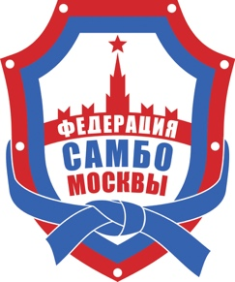
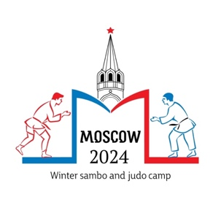

Open sambo and judo training camp

3-6 January 2024 Moscow

REQUEST
ACCOMMODATION

Responsible for accommodation  Pavlov Denis - +79067722514 | E-mail: sambo70camp@mail.ru

Federation/Club |  | Contact
City |  | Telephone
Email |  | Mob. wire.

Total number of participants |  | 10
Coaches, representatives |  | 2
Female athletes |  | 8
Male athletes |  | 2

Hotel category:
 | Single rooms: |  | Double rooms: |  | Triple rooms:
Requested

quantity
Arrival: |  | Departure: |  | Number of nights:
3.01.2024 |  | 6.01.2024 |  | 3

Applications for accommodation should be sent to e-mail no later than 18.12.2024.

